This QRG explains how to…
- Access Open Resourcing when using non GI-D device:
- With a Shell GI-Smartcard
- Without a Shell GI-Smartcard and with a mobile phone
- Without a Shell GI-Smart card and without a mobile phone
- Navigate the Open Resourcing System
Note: if you do not have a Shell GI-Smartcard AND you do not have an active OTP account, you must first create an account using the QRG How to set up and OTP account as an NOV user

1 | - I have a GI-Smartcard
 | Getting Started | - If you are accessing Open Resourcing for the first time, contact HR Services to request access
2 | Access Open Resourcing | - Once access has been granted (or you have previously accessed Open Resourcing), go to Open Resourcing  - Click on the Smartcard option  - You will be taken to the Open Resourcing Welcome page  - See the Navigate Open Resourcing section of this document for details on how to navigate the Open Resourcing system | 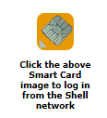

1 | - I have my mobile device (for users without a GI-Smartcard)
 | Access Open Resourcing | - Go to Open Resourcing  - Select the OTP authentication option  - Enter your username (email address)  - Go to the application on your mobile device (See step 2 below) and generate a new one time password  Please note  - If you do not have access to your mobile device, office email, please see the section in this document, Set-up OTP account without a mobile phone (for users without a Shell GI-Smartcard AND without an OTP account) | 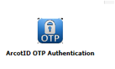  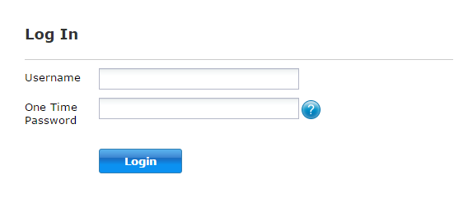
2 | Generate One Time Password | - Open the app on your mobile device, enter your 6 digit security PIN to generate a onetime password (note this is valid for only 30 seconds  - Enter this code in the One Time Password field  - Click Login | 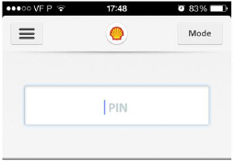  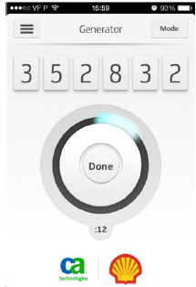

1 | - I do not have my mobile device (for users without a GI-Smartcard)
 | Go to Open Resourcing | - Open Resourcing  - Select the OTP icon | 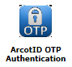
2 | Set-up security code | - On the Log In screen, click the blue question mark icon next to the password field | 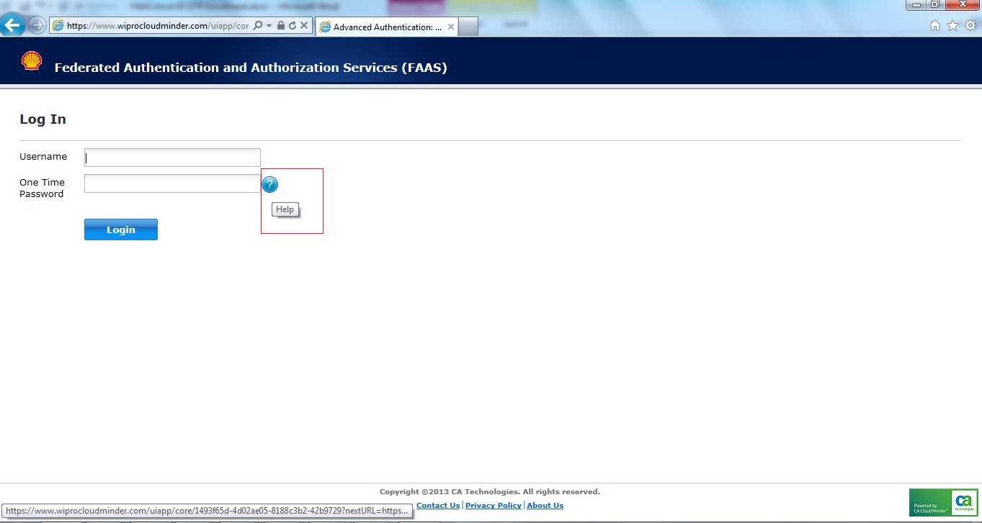
 | Set-up security code | - On the following screen, click the My phone is unavailable option | 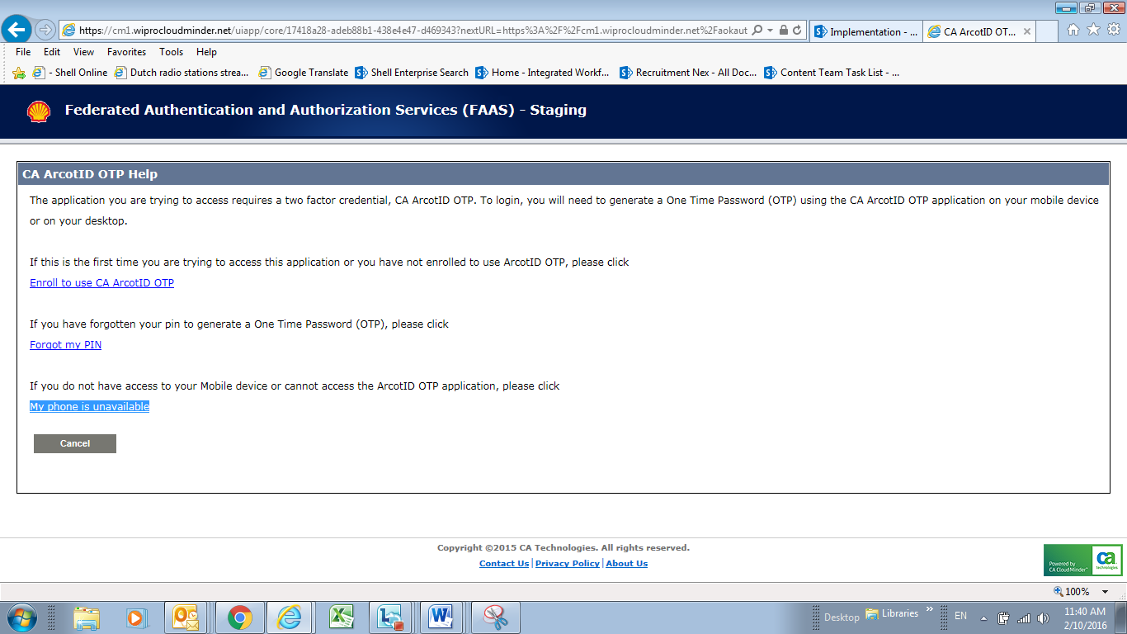
 | Set-up security code | - Enter your username  - Click Continue | 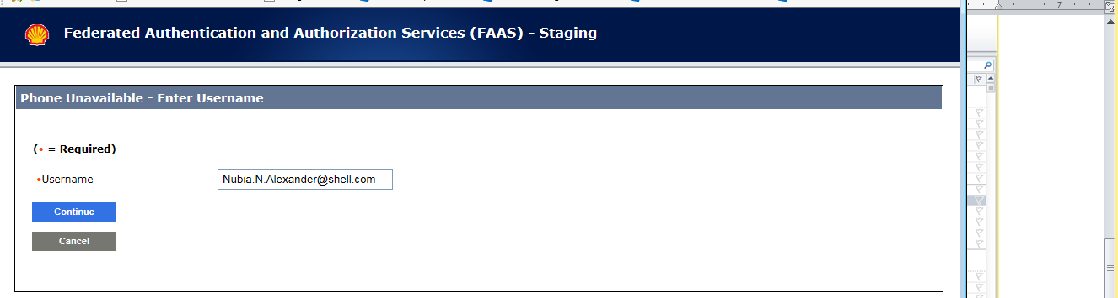
 | Set-up security code | - Go to your email to pick up the security code required to complete this step  - Enter the security code  - Click Submit | 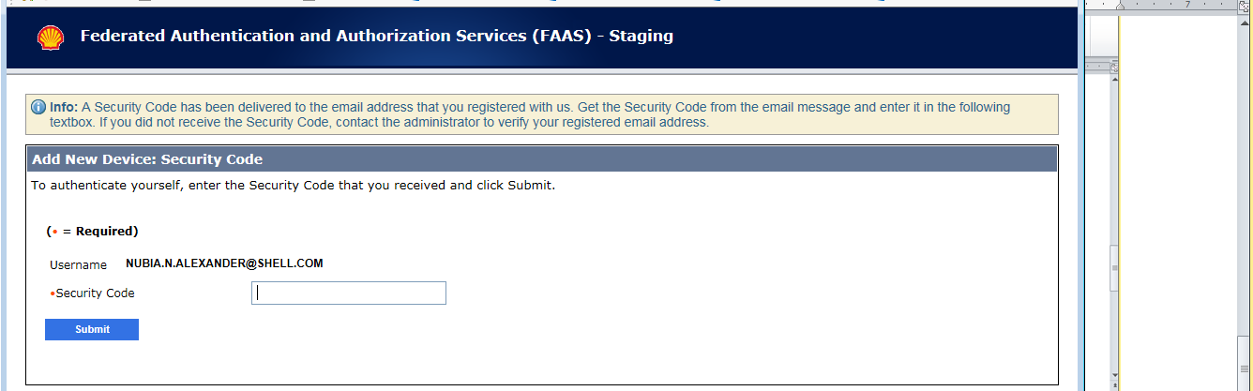
3 | Log into Open Resourcing | - On the Log In screen, enter the PIN you created when you first set up your OTP account  - Click Login  - You will see the Open Resourcing welcome screen | 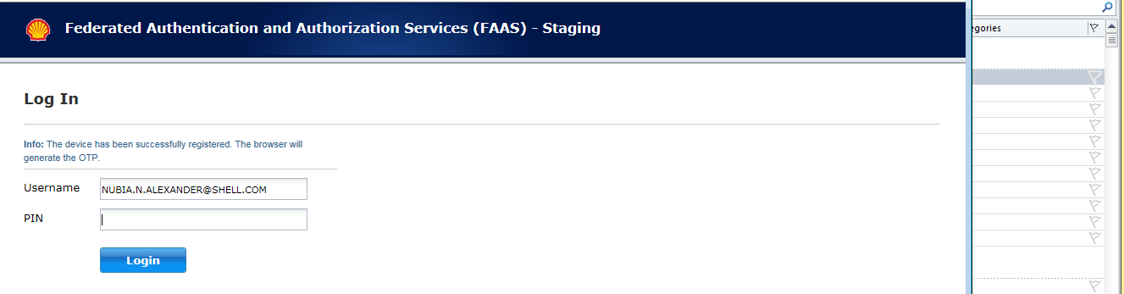

1 | Navigate Open Resourcing
 | Navigate the system | From the Welcome page, you can navigate to the following areas  - Shell Open Resourcing for Joint Venture Partners to search and apply for available vacancies  - Candidate Zone to access the following:  - Search openings to search for all available vacancies in the system  - Resume/CV Manger where you can edit or delete saved CV’s  - Search agent manager to set your search filters  - Job cart to view jobs you have previously saved  - Saved drafts to view saved application to be completed at a later time | 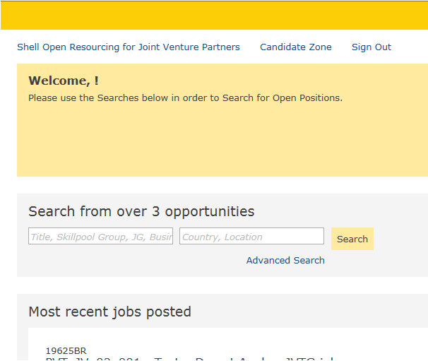  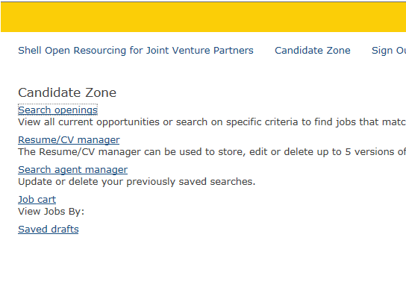

Learn more
- Search and apply for jobs QRG and video
- For further assistance, please contact your NOV HR contact or HR Services
- Americas
Email: hr-services@shell.com
Telephone :
- For Americas/Philippines:
- From US, Bermuda, Barbados, Trinidad and Tobago: (866) 514-7135
- From Canada: +1 800 663 9898
- From Brazil: +55 21 3984 8001 (Brazil)
- From Latin America: +63 2 490 4571
- From Philippines: +63 2 490 4800
- Europe
Email: hr-services@shell.com
Telephone: +48 12 378 51 00

- Asia Pacific, Middle East and Oceania
Email : hr-services@shell.com
Telephone : +603 8688 6000

