This QRG explains how to…
Set up an OTP account to access the Open Resourcing system with non GI-D device user in the following scenarios
- With a mobile phone
- Without a mobile phone

1 | - Set-up OTP account with a mobile phone (for users without a Shell GI-Smartcard )
 | Getting started | - You will need a mobile device (e.g., phone, tablet) to complete your registration  - Send an email to HR Services (contact details provided at the end of this document), to request a FAAS account and password activation in order to access Open Resourcing via OTP  - You will receive an email with a Server URL, User Identifier and Activation code  - Note the information contained therein as you will need to complete your registration | 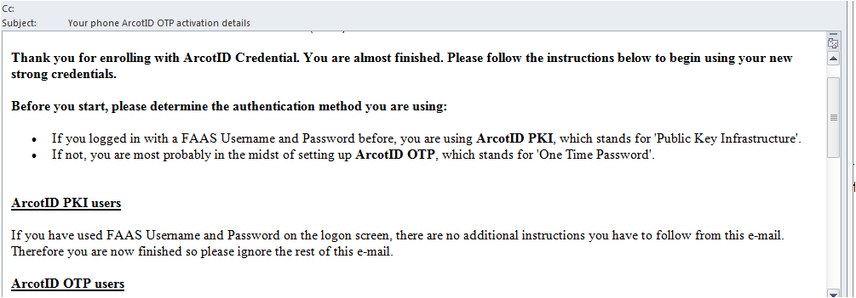
2 | Download the OTP application | - Download the ArcotID OTP application for free from your mobile device specific application store.  - For iPhone or iPad: App Store  - For Android: Google Play  - For Blackberry: App World
3 | Configure the application | - After installing the application, open the application by selecting the AcrotID OTP icon  - Agree to the terms and conditions | 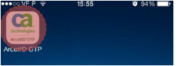  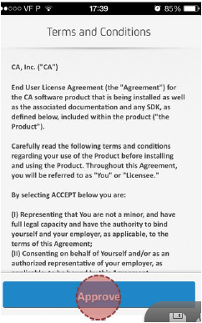
 |  | - Go to the email from you received after requesting an account:  - In the application on your mobile device, enter the Server URL  - Enter the User identifier and click Next (or Save on a Blackberry)  - Then enter the Activation code and click Next (or Save on a Blackberry)  Please note:  - Icons and screens may appear differently on a blackberry or android device, but the steps remain the same | 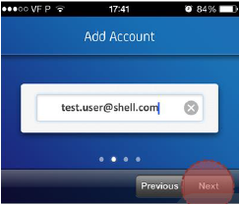  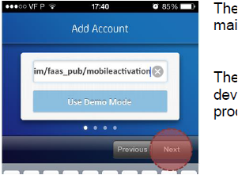  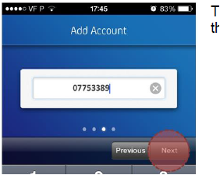
 |  | - If all information above has been correctly entered you will be prompted to define the security PIN  - Enter a security PIN of your choice (minimum length is 6 digits) and click Next ( or Done on a Blackberry)  - You are successfully registered and ready to generate new One Time Passwords (OTPs) when you see the screen with the Shell pecten | 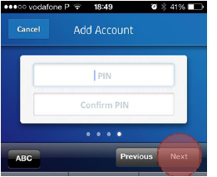  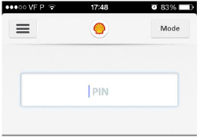
4 | Accessing Open Resourcing | - Go to Open Resourcing  - Select the OTP authentication option  - Enter your username (email address)  - Go to the application on your mobile device (See step 5 below) and generate a new one time password  Please note  - If you do not have access to your mobile device, office email, please see Section 4.Set-up OTP account without a mobile phone (for users without a Shell GI-Smartcard AND without an OTP account) | 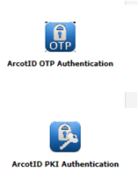  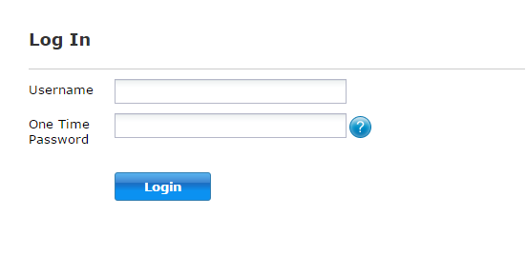
5 | Generate One Time Password | - Open the app on your mobile device, enter your 6 digit security PIN to generate a onetime password (note this is valid for only 30 seconds  - Enter this code in the One Time Password field  - Click Login | 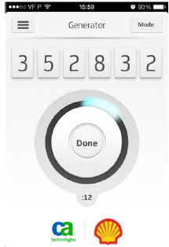

1 | - Set-up OTP account without a mobile phone (for users without a Shell GI-Smartcard)
 | Getting started | - Send an email to HR Services (contact details provided at the end of this document) to request a FAAS account and password activation in order to access Open Resourcing via OTP  - You will receive two emails:  - One contains Server URL, User Identifier and Activation code  - The second contains Password details  - Note the information contained therein as you will need it to complete your registration | 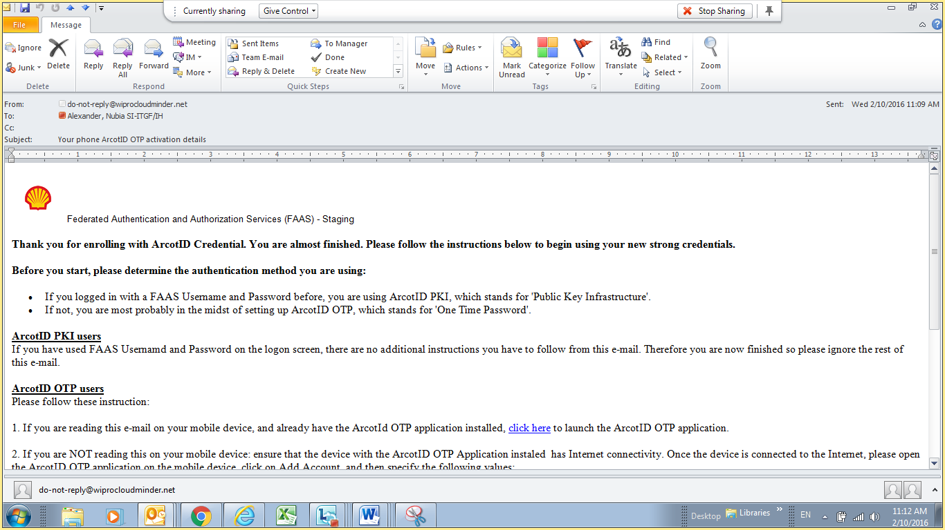
2 | Go to Open Resourcing | - Go to Open Resourcing  - Select the OTP icon  - On the Log In screen, click the blue question mark icon next to the password field | 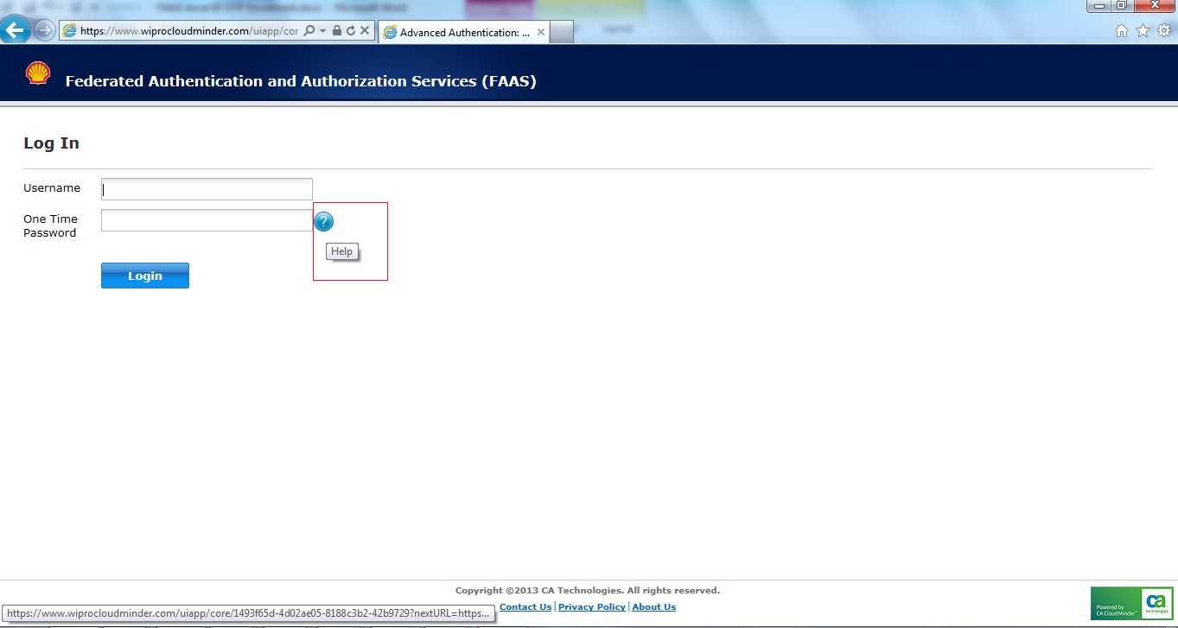
3 | Complete OTP enrollment | - On the following screen, click Enroll to use CA ArcotID OTP | 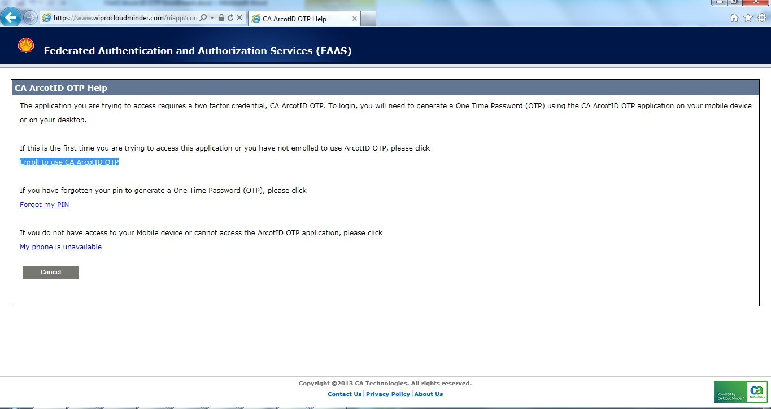
 |  | - Enter your User Identifier from the email in the Username field  - Enter the Password from the email in the Password field  - Complete the Captcha field and click ok | 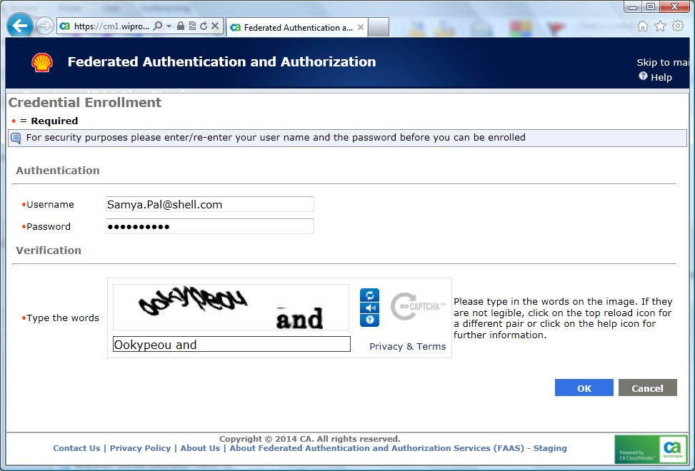
 |  | - In the AcrotID OTP section of the screen, enter a password of your choosing (minimum 6 digits) in the PIN field  - Confirm the PIN is correct by re-entering it in the Confirm PIN field | 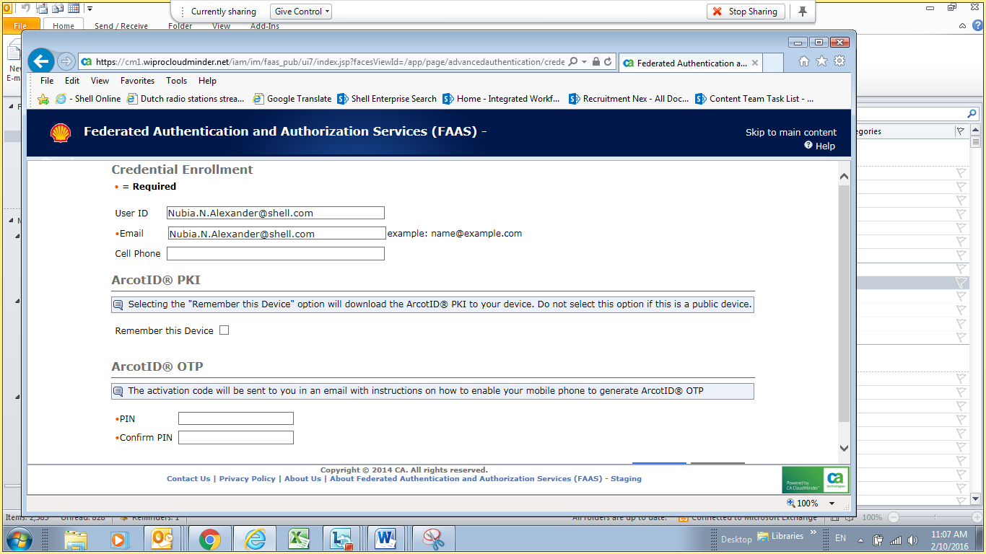
 |  | - If the two fields match, you will see the confirmation on screen  - Click Ok  - To access Open Resourcing, go to the Quick Reference Guide How to access and Navigate Open Resourcing as an NOV user(HR) | 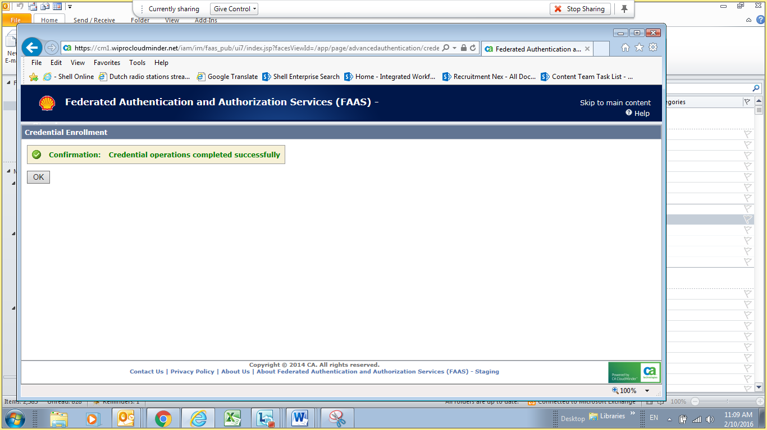

Learn more
- How to access and Navigate Open Resourcing as an NOV user(HR)
- Search and apply for jobs QRG and video
- For further assistance, please contact your NOV HR contact or HR Services
- Americas
Email: hr-services@shell.com
Telephone :
- For Americas/Philippines:
- From US, Bermuda, Barbados, Trinidad and Tobago: (866) 514-7135
- From Canada: +1 800 663 9898
- From Brazil: +55 21 3984 8001 (Brazil)
- From Latin America: +63 2 490 4571
- From Philippines: +63 2 490 4800
- Europe
Email: hr-services@shell.com
Telephone: +48 12 378 51 00

- Asia Pacific, Middle East and Oceania
Email : hr-services@shell.com
Telephone : +603 8688 6000

